

STAREHE GIRLS’ 2025 PREDICTION
POSSIBLE KCSE EXAM
312/1
GEOGRAPHY
PAPER 1
TIME: 2¾ HOURS

NAME……………………………………………………………………………………….
SCHOOL……………………………………………… SIGN………………………..
INDEX NO……………………………………………. ADM NO……………………

(Kenya Certificate of Secondary Education)

INSTRUCTIONS TO CANDIDATES
- This paper has two sections: A and B.
- Answer all the questions in section A.
- Answer question 6 and any other two questions from section B.
- All answers must be written in separate answer sheets provided.

SECTION A
Answer all questions in this section
1. (a) What is the relationship between Geography and Physics. (2 marks)
(b) Name three main layers of the atmosphere from the earth’s surface upwards. (3 marks)
2. The diagram below shows a barchan.
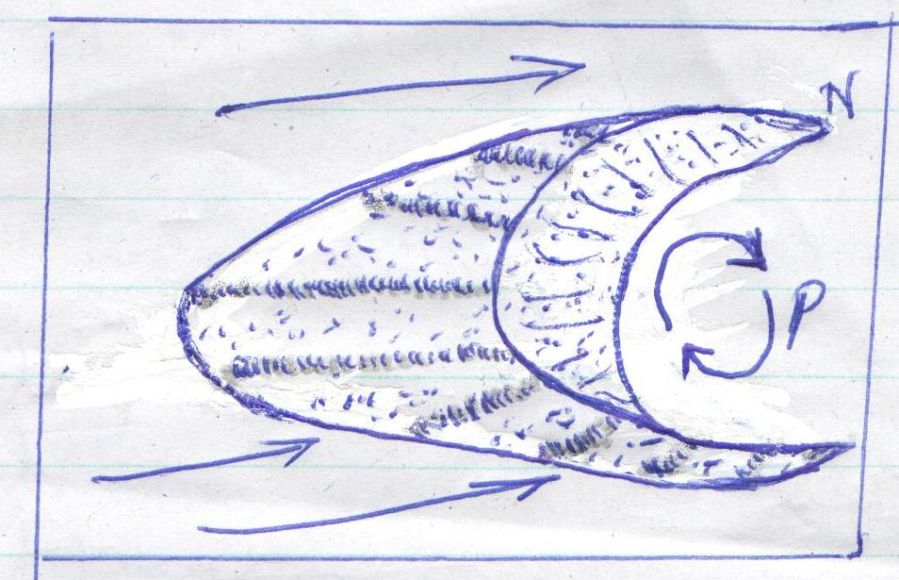

(a) Name the feature marked N. (1 mark)
(b) Name the air currents marked P. (1 mark)
(c) Give three reasons why wind erosion is dominant in hot deserts (3 marks)

3. (a) Differentiate between vulcanicity and volcanicity? (2 marks)
(b) State three effects of vulcanicity on agriculture (3 marks)

4. (a) State three causes of earth movements (3 marks)
(b) Name two main earthquake zones in world (2 marks)

5. (a) Define the term oceans (2 marks)
(b) State three reasons why ocean waters are salty (3 marks)

SECTION B
Answer question 6 and any other two questions from this section
6. 6. Study the map of TAMBACH, 1:50,000 and answer the following questions
a. What is the title of the map provided (1 Mk)
b. (i)Name two types of scales found on the map (2Mks)
(ii)Convert the scale of the map into statement scale (2 Mks)
c. (i) What is the magnetic declination of the map as at 1980 (2 Mks)
(ii)Name the index number and the area bordering Tambach to the east (1 Mk)
d. (i)Identify two human features found on the grid square7979 (2 Mks)
(ii)State the six-figure grid reference for the school at Kapluk (2Mks)
e.(i) Describe the relief of the area covered by the map (5 Mks)
(ii)Citing evidence from the map, describe the social functions of Tambach town (3 Mks)
f. Using a vertical scale of 1cm representing 40 metres, draw a cross section from grid reference 830610 to grid 890610. On the cross section, mark and label the following features (5 Mks)
  - Road C52
  - Foot path
  - River Torok
  - Hill

7. (a) (i) Apart from simple fold, name three other types of fold. (3 marks)
(ii) Identify two characteristics of simple fold. (2 marks)
(iii) Give two factors that influence the magnitude of folding (2 marks)
(b) Mention three fold-mountain forming periods. (3 marks)
(c) (i) Using a well-labelled diagram, describe the formation of a fold mountain. (7 marks)
(ii) State three significance of fold mountain to man (3 marks) (d) suppose you carried out a field study in an area affected by folding.
(i) List three methods you used to collect data. (3 marks)
(ii) Give two reasons why you could conduct a pre-visit. (2 marks)

8. (a) (i) What is soil catena? (2 marks)
(ii) Give three components of soil. (3 marks)
(b) (i) List characteristics of desert soils. (3 marks)
(ii) Give two factors that contribute to soil leaching (2 marks)
(c) (i) state two economic uses of soils. (2 marks)
(ii) Explain how the following farming practices may lead to loss of soil fertility:
- Overgrazing (2 marks)
- Frequent ploughing (2 marks)
- Continuous irrigation (2 marks)
(d) You are supposed to carry out a field study of an eroded area.
(i) What information would you collect through observation that would indicate that the area is severely eroded? (3 marks)
(ii) State four recommendations you would give to control soil erosion. (4 marks)

9. (a) (i) List any three sources of underground water (3marks)
(ii) Differentiate pervious rocks from porous rocks (2marks)
(b) Explain four factors that influence the occurrence of underground water. (8marks)
(c) (i) Mention any three factors necessary for the formation of karst features. (3marks)
(ii) List any three underground features of karst areas (3marks)
(d) Explain any three significance of karst features to man. (6marks)

10. (a) What is river capture? (2 marks)
(b) (i) List three types of meanders at a lower course of a river. (3 marks)
(ii) State three factors influencing the rate of erosion. (3 marks)
(c) (i) Give three processes of river erosion (3 marks)
(ii) Describe four processes through which a river transports its load (8 marks)
(d) Explain three negative influences of rivers on human activities (6 marks)

